**Smart Streetlight Management Using IBM Watson**

Team:-Startic

Teamname:

* Sandeep Reddy
* Sai Krishna
* Kushal

# ABSTRACT

In the present field technologies, the main considerations are automation, power consumption and cost effectiveness. Automation is intended to reduce man power with the help of intelligent systems. Power saving is the main consideration forever as the source of the power is getting diminished due to various reasons. This paper illustrates the designing of a smart street light scheme with IOT based monitoring and thus executing the advanced development in embedded systems. A smart street lighting infrastructure includes Internet Protocol connectivity via gateways, which enables remote management of individual lights by monitoring environmental conditions, such as light, fault and pollution level. By means of monitoring each and every street light such as power failure, bulb damage and circuitry problems can be detected by monitoring whether the light is working or not and check the status of the sunlight and the artificial lamp (street lamp) by using LDR as light sensor. More than 50 percentages of energy and maintenance cost can save by adding some intelligence to lights. Also, a demonstration with a realtime prototype model involving costs and implementation procedure has been developed using Internet of Things to visualize the real time updates of street processing and notifying the changes occur.

## INTRODUCTION

The street light system is one of the major elements in every cities and small towns. There is nothing to explain the importance of street light, but the present system is having number of drawbacks. Primarily, most of the street light systems are manually operated which have to be activated by human being either locally or from a centralized point. At the same time, they do not have any feedback system through which it could be identify the functioning and non-functioning street light unit.

A system will be highly beneficial if the street light can be controlled from a centralized location remotely without wire connectivity. The wireless connectivity is again distinctly useful if the street lights are powered by battery back-up and solar energy. In case of street lights in many places conventional street lights are replaced by automatic street light which is based on light intensity sensor. This is a noble way to minimize the wastage of power, manpower as well as increase the life of the light unit (indirectly). But these systems are not having in built monitoring system i.e. whether the light is actually working or not. It is a very common phenomenon where we have found that street light is installed but many of the units are not in working condition, it is due to lack of proper maintenance and ignorance about the faulty system. A system with self-monitoring system and remote controlling can be improved a street light system up to an extent.

## SMART STREET LIGHT

Smart street light refers to public street lighting that adapts to movement by pedestrians, cyclists and cars. Intelligent street lighting also referred to as adaptive street lighting, dims when no activity is detected, but brightens when movement is detected. This type of lighting is different from traditional, stationary [illumination,](https://en.wikipedia.org/wiki/Illumination_(lighting)) or dimmable street lighting that dims at pre-determined times. Smart street light system tries to find solution for the faster depletion of energy resources due to the inefficient usage and wastage of these resources. Increasing electricity bill is something that can be witnessed by these practices. This paper helps to decrease the wastage of electricity by controlling the working of street light system that attributes to a good amount of electricity. Street lights can be made intelligent by placing [cameras](https://en.wikipedia.org/wiki/Camera) or other [sensors](https://en.wikipedia.org/wiki/Sensors) on them, which enables them to detect. The other advantage of LED is that the intensity can be controlled easily.

## BLOCK DIAGRAM

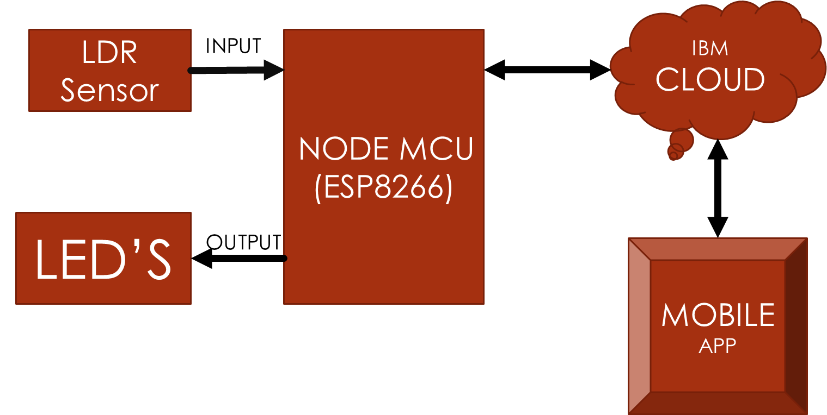

## WORKING PRINCIPLE

The main principle behind this is nothing but the working of the LDR sensor it is the sensor which is used to detect the intensity of the light falling on it.in this project we use the LDR values to control the intensity of the LED to which we give the connections. This same principle can be implemented in street lights The main intension of this is to save the power by dimming the lights when its day time or else when not needed. It can be controlled manually as well as in automatic way.

**HARDWARE COMPONENTS**

*NODE MCU

*LDR

*LED

**SOFTWARE COMPONENTS**

*ARDUINO IDE

*ANDROID STUDIO

*IBM WATSON CLOUD SERVICES

**SERVICES**

*IOT PLATFORM

*NODE RED UI

\***NODE MCU:-**

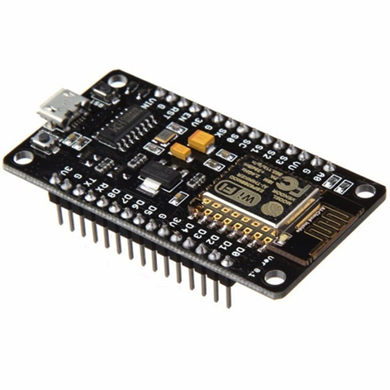Node MCU is an open source IoT platform. It includes firmware which runs on the ESP8266 Wi-Fi SOC from Espress if Systems, and hardware which is based on the ESP-12 module. The term "NodeMCU" by default refers to the firmware rather than the development kits. The firmware uses the Lua scripting language. It is based on the eLua project, and built on the Espressif Non-OS SDK for ESP8266. It uses many open source projects, such as lua-cjson[8] and SPIFFS. NodeMCU was created shortly after the ESP8266 came out. On December 30, 2013, Espressif Systems[6] began production of the ESP8266. The ESP8266 is a Wi-Fi SoC integrated with a Tensilica Xtensa LX106 core,[citation needed] widely used in IoT applications (see related projects). NodeMCU started on 13 Oct 2014, when Hong committed the first file of nodemcu-firmware to GitHub. Two months later, the project expanded to include an open-hardware platform when developer Huang R committed the gerber file of an ESP8266 board, named devkit v0.9.Later that month, Tuan PM ported MQTT client library from Contiki to the ESP8266 SoC platform, and committed to NodeMCU project, then NodeMCU was able to support the MQTT IoT protocol, using Lua to access the MQTT broker. Another important update was made on 30 Jan 2015, when Devsaurus ported the u8glib to NodeMCU project, enabling NodeMCU to easily drive LCD, Screen, OLED, even VGA displays.In summer 2015 the creators abandoned the firmware project and a group of independent contributors took over. By summer 2016 the NodeMCU included more than 40 different modules. Due to resource constraints users need to select the modules relevant for their project and build a firmware tailored to their needs. As Arduino.cc began developing new MCU boards based on non-AVR processors like the ARM/SAM MCU and used in the Arduino Due, they needed to modify the Arduino IDE so that it would be relatively easy to change the IDE to support alternate toolchains to allow Arduino C/C++ to be compiled for these new processors. They did this with the introduction of the Board Manager and the SAM Core. A "core" is the collection of software components required by the Board Manager and the Arduino IDE to compile an Arduino C/C++ source file for the target MCU's machine language. Some ESP8266 enthusiasts developed an Arduino core for the ESP8266 WiFi SoC, popularly called the "ESP8266 Core for the Arduino IDE". This has become a leading software development platform for the various ESP8266-based modules and development boards, including NodeMCUs.

NodeMCU provides access to the GPIO (General Purpose Input/Output) and a pin mapping table is part of the API documentation.

|  |  |
| --- | --- |
| **I/O index** | **ESP8266 pin** |
| 0 [*] | GPIO16 |
| 1 | GPIO5 |
| 2 | GPIO4 |
| 3 | GPIO0 |
| 4 | GPIO2 |
| 5 | GPIO14 |
| 6 | GPIO12 |
| 7 | GPIO13 |
| 8 | GPIO15 |
| 9 | GPIO3 |
| 10 | GPIO1 |
| 11 | GPIO9 |
| 12 | GPIO10 |

**\*LDR SENSOR :-**

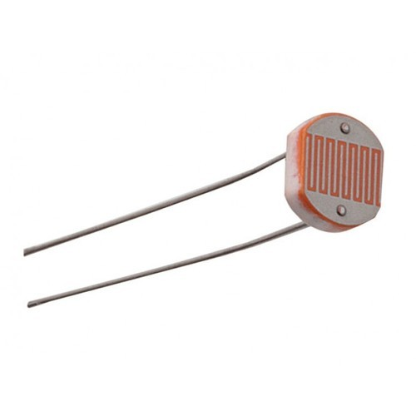A photoresistor (or light-dependent resistor, LDR, or photo-conductive cell) is a light-controlled variable resistor. The resistance of a photoresistor decreases with increasing incident light intensity; in other words, it exhibits photoconductivity. A photoresistor can be applied in light-sensitive detector circuits, and light-activated and dark-activated switching circuits.A photoresistor is made of a high resistance semiconductor. In the dark, a photoresistor can have a resistance as high as several megohms (MΩ), while in the light, a photoresistor can have a resistance as low as a few hundred ohms. If incident light on a photoresistor exceeds a certain frequency, photons absorbed by the semiconductor give bound electrons enough energy to jump into the conduction band. The resulting free electrons (and their hole partners) conduct electricity, thereby lowering resistance. The resistance range and sensitivity of a photoresistor can substantially differ among dissimilar devices. Moreover, unique photoresistors may react substantially differently to photons within certain wavelength bands.A photoelectric device can be either intrinsic or extrinsic. An intrinsic semiconductor has its own charge carriers and is not an efficient semiconductor, for example, silicon. In intrinsic devices the only available electrons are in the valence band, and hence the photon must have enough energy to excite the electron across the entire bandgap. Extrinsic devices have impurities, also called dopants, added whose ground state energy is closer to the conduction band; since the electrons do not have as far to jump, lower energy photons (that is, longer wavelengths and lower frequencies) are sufficient to trigger the device. If a sample of silicon has some of its atoms replaced by phosphorus atoms (impurities), there will be extra electrons available for conduction. This is an example of an extrinsic semiconductor. Photoresistors are less light-sensitive devices than photodiodes or phototransistors: the two latter components are true semiconductor devices, while a photoresistor is a passive component and does not have a PN-junction. The photoresistivity of any photoresistor may vary widely depending on ambient temperature, making them unsuitable for applications requiring precise measurement of or sensitivity to light photons.Photoresistors also exhibit a certain degree of latency between exposure to light and the subsequent decrease in resistance, usually around 10 milliseconds. The lag time when going from lit to dark environments is even greater, often as long as one second. This property makes them unsuitable for sensing rapidly flashing lights, but is sometimes used to smooth the response of audio signal compression.Photoresistors come in many types. Inexpensive cadmium sulfide cells can be found in many consumer items such as camera light meters, clock radios, alarm devices (as the detector for a light beam), nightlights, outdoor clocks, solar street lamps and solar road studs, etc.Photoresistors can be placed in streetlights to control when the light is on. Ambient light falling on the photoresistor causes the streetlight to turn off. Thus energy is saved by ensuring the light is only on during hours of darkness.They are also used in some dynamic compressors together with a small incandescent or neon lamp, or light-emitting diode to control gain reduction. A common usage of this application can be found in many guitar amplifiers that incorporate an onboard tremolo effect, as the oscillating light patterns control the level of signal running through the amp circuit.The use of CdS and CdSe photoresistors is severely restricted in Europe due to the RoHS ban on cadmium.Lead sulfide (PbS) and indium antimonide (InSb) LDRs (light-dependent resistors) are used for the mid-infrared spectral region. Ge:Cu photoconductors are among the best far-infrared detectors available, and are used for infrared astronomy and infrared spectroscopy.

**\*LED’S:-**

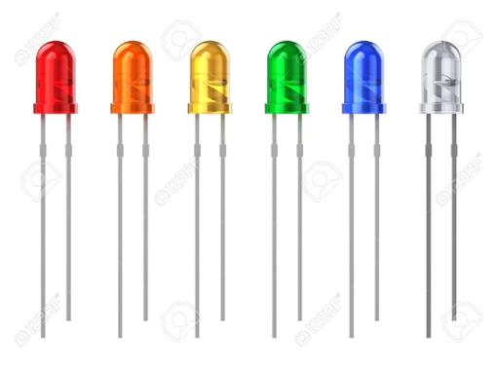A light-emitting diode (LED) is a semiconductor light source that emits light when current flows through it. Electrons in the semiconductor recombine with electron holes, releasing energy in the form of photons. This effect is called electroluminescence.The color of the light (corresponding to the energy of the photons) is determined by the energy required for electrons to cross the band gap of the semiconductor. White light is obtained by using multiple semiconductors or a layer of light-emitting phosphor on the semiconductor device.Appearing as practical electronic components in 1962, the earliest LEDs emitted low-intensity infrared light.Infrared LEDs are used in remote-control circuits, such as those used with a wide variety of consumer electronics. The first visible-light LEDs were of low intensity and limited to red. Modern LEDs are available across the visible, ultraviolet, and infrared wavelengths, with high light output. Early LEDs were often used as indicator lamps, replacing small incandescent bulbs, and in seven-segment displays. Recent developments have produced white-light LEDs suitable for room lighting. LEDs have led to new displays and sensors, while their high switching rates are useful in advanced communications technology. LEDs have many advantages over incandescent light sources, including lower energy consumption, longer lifetime, improved physical robustness, smaller size, and faster switching. Light-emitting diodes are used in applications as diverse as aviation lighting, automotive headlamps, advertising, general lighting, traffic signals, camera flashes, lighted wallpaper and medical devices.

.